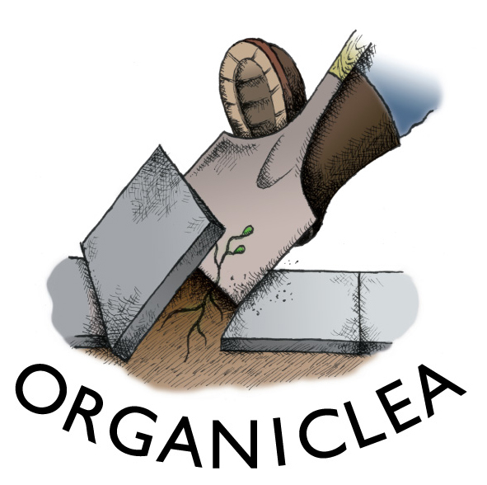
Trainee Role Description – Grower, Fruit and Vines

We grow organic produce at Hawkwood, our 12 acre community market garden and plant nursery, and distribute it to our own market stalls, box scheme and local restaurants. We have an orchard of over 200 young fruit trees; peaches fan trained against our glasshouse; cordons of apples and pears; almonds and hazelnuts; soft fruit from blackcurrants to worcester berries. Our vineyard has been planted with nearly 500 vines, for eating and drinking, and in 2013 we installed a winery and started making our own wine.

This traineeship will suit someone looking to develop their skills as a fruit and vine grower in a community setting and in the organic viticulture and fruit growing. The trainee will learn the skills required to manage the vineyard and fruit growing areas of Hawkwood, and take on responsibilities for the fruit and vines.

Details of the role
- Unpaid voluntary role
- Time commitment: 1 day/week for 9 months
- Dates: Friday 4th April- Friday 12th December 2014
- Hours: Fridays from 9.00am - 5.00pm
- Based at: Hawkwood Community Plant Nursery
- Occasional weekend commitments: 4 days over the traineeship to support weekend outreach events, Open Day and plant and produce stalls
- Supported by: trainee tutorials one evening per month and monthly check-ins with an Organiclea mentor

Main objectives

To learn about and assist with all aspects of planting, preparation and maintenance of the vineyard and soft and top fruit areas at Hawkwood

To learn about and assist with harvesting and processing of fruit from Hawkwood and scrumped from trees in streets and gardens in the borough

To assist with the morning vegetable and flower harvest and with the vegetable production when the season requires

To provide support for the volunteer programme

Main Activities
Fruit and vineyard
- Planting vines, trees and fruit bushes
- Pruning
- Training restricted forms
- Orchard management
- Propagation from cuttings
- Wine and juice production
- Organic weed, pest and disease management
- Assisting with development and maintenance of the site’s infrastructure
- Undertake other activities in support of Organiclea, as appropriate

Scrumping
- Take part in fruit picking around the borough
- Sort the fruit into storing and juicing quality
- Keep good records of fruit available, picks undertaken and amounts juiced
- Help to process scrumped fruit into juice

Growing
- Assist with the harvesting of fruit, vegetables and flowers to agreed methods, ensuring quality control
- Weighing, packaging, sealing, labelling and organising despatch of produce
- Assist with all aspects of vegetable production including: formulating propagation media, raising plants from seed, planting, harvesting, weeding and maintaining salad crops, vegetables, green manures and companion plants

Working with volunteers
- Work to ensure all volunteers on site are safe, welcomed, valued and supported
- Lead tasks with volunteers

Person Specification

Essential
- Interest in sustainable food production and the desire to put that interest into practice
- Some experience of growing
- Ability to supervise and explain tasks to volunteers
- Happy to work mainly outdoors throughout the year
- Ability to carry out shared tasks and work within a team
- Ability to work on own initiative, prioritise tasks and work to deadlines
- Commitment to and understanding of the aims of Organiclea

Desirable
- Experience of working with volunteers

