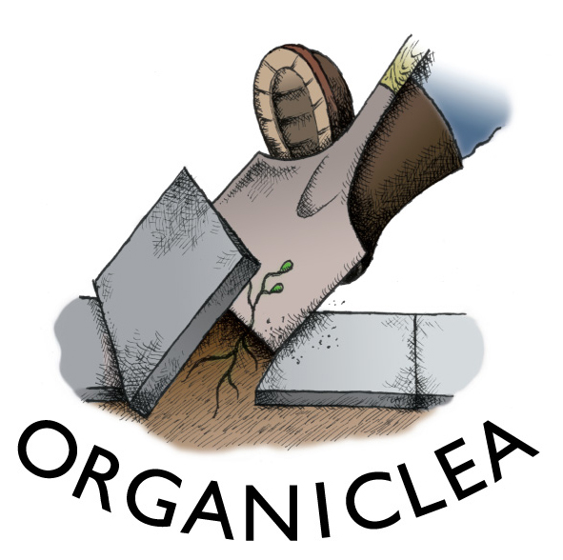
Food Growing Essentials:
Plants and Planks

Get a helping hand on your plot this growing season with locally grown food plants, compost and garden structure resources. See below for plants and compost on offer this year, and turn over for details of structure resources, how to order and delivery details.

FOR HARVEST IN SUMMER-AUTUMN (available May-June) |  | Price | Quantity
Aubergine |  | £1.75
Beans  Runner beans, climbing french beans, dwarf french beans |  | 3 plants per pot  £4 per pot
Range of companion flowers  Eg: calendula, borage, nasturtium, California poppy, nigella, and sunflower |  | £1 - £1.50
Courgette (early season)  Eg of variety: Nero di milano, yellow straight neck |  | £2
Cucumber (outdoor growing variety) |  | £2
Globe artichokes |  | £1.50 - £2
Kitchen Herbs – Basil and Parsley |  | Small pots 75p
Peppers (hot – chilli) Eg of variety: Ring of fire, purple |  | £1.75
Peppers (sweet) Eg of variety: Long red marconi |  | £1.75
Salad plants – ONLY FOR SALE TO ORDER |  | 40p a plug
Squash (several varieties and pot sizes)  Eg of variety: Butternut, trombolino, green hokaido |  | £1.50-£2
Sweetcorn  Eg of variety: Golden Bantum |  | 3 plants per pot  £2 a pot
Tomatoes Eg of varieties: Tiger tom, gardener’s delight, san marzano, tumbling tom |  | £1.75
FOR HARVEST IN WINTER (available in August)
Cabbage (large pot plants) |  | £3.50 - £4
Kale (large pot plants) |  | £3.50 - £4
Selection of winter salads |  | Plugs – 40p each  £1 a pot plant
FOR THE FRUIT GARDEN (available May – September)
Grape vines |  | £5 - £8
Blackcurrant (2 year old plants) |  | £4.50
Worcesterberries (in the gooseberry family: high yielding large red gooseberries) |  | £3 - £4.50
Raspberry canes |  | £3
Strawberry plants |  | £1.50/£2.50
Rhubarb plants |  | £3.50 / £4.50
COMPOSTS – HAND-MADE AND BAGGED-UP AT HAWKWOOD
Seed compost (20L sack) Organic (Og), peat free (PF), animal free (AF) |  | £5
Potting-on compost (perfect for transplanting seedlings): 20L/40L (Og, PF, AF) |  | £5/£9
Garden compost - Soil improver (add before plants go in to a space) 40L (PF, AF) |  | £5 (5 sacks £20)
Wood chip bark (decorative and biodegradable mulch) 40L |  | £2
Garden structure resources |  | Price | Quantity
Scaffold boards | Reclaimed boards ranging in length from approx 3ft to 10ft | From £1.00
Hessian Sacks | Used coffee bean sacks, useful as mulch, screens or even as sacks | £1.00
Paint | Reclaimed paint. All types available including masonry, woodstains, fence paint, gloss | £1.00 per litre
Tyres | Reclaimed tyres. Useful as wormeries or containers (especially potato stacks) | £1.00
Pallets | Waste pallets, useful for compost bins and other structures | £2.00
Bird boxes | Made from scrap wood | £4.00
Window boxes | Made from scrap wood | From £3.00
We are also may be able to procure
Containers | Old plant pots, and scrap items that can double up as containers eg mushroom crates
Water butts | Old 1 meter cubed catering containers
Wheelie bins | Slightly damaged bins
Plastic water bottles | 5 ltr bottles. Useful as cloches
Cardboard | Waste cardboard. useful for mulch
Netting | Reclaimed from scaffolding operations on building sites
Scrap wood
Manure
Other items | Let us know what you need and we’ll see if we can source it!

Our plants: We grow all the plants ourselves in our glasshouse that we rent from the London Borough of Waltham Forest. Work is carried out by a team of growers including members of our workers’ cooperative and lots of local volunteers who support the project’s aim to encourage more food growing in London. Plants are taken from the glasshouses and acclimatised to the outdoors before being dispatched. The plants are strong and healthy, ready to compete effectively with weed seedlings and garden pests! We can provide aftercare tips with the plants on request.

Delivery: We can deliver larger orders. Cost for delivery (to cover fuel and driver costs) from £10 depending on distance.

Bulk order discounts: £200+ (5% off); £300+ (10% off); 400+ (15% off); £500+ (20% off)

How to buy:
* Contact Clare at Organiclea’s Hawkwood site to order plants.
Call 020 8524 4994, email plants@organiclea.org.uk or bring this order form to the site. You can also buy plants and compost direct from one of our plant stalls in May-June 2011 in Northeast London. (contact us or check on www.organiclea.org.uk for details). Special requests: We can sow to order for local gardening projects if we hear from you before mid-April (stock ready by early June).
* Contact Brian at Forest Recycling Project to order structure resources.
Call 020 8539 3856 or email brian@frponline.org.uk

Name:
Tel number: | Email:

